Categories

1. [Basic Statistics](https://datascienceplus.com/category/basic-statistics/)

Tags

1. [Data Visualisation](https://datascienceplus.com/tag/data-visualisation/)
2. [Import Data](https://datascienceplus.com/tag/import-data/)
3. [R Programming](https://datascienceplus.com/tag/rstats/)

This is the second part of the 4-series articles about Dow Jones Stock Market. To read the first part go to this [link](https://datascienceplus.com/dow-jones-stock-market-index-1-4-log-returns-exploratory-analysis/). In this part, I am going to analyze the Dow Jones Industrial Average (DJIA) trade volume.

**Packages**

The packages being used in this post series are herein listed.

suppressPackageStartupMessages(library(lubridate))

suppressPackageStartupMessages(library(fBasics))

suppressPackageStartupMessages(library(lmtest))

suppressPackageStartupMessages(library(urca))

suppressPackageStartupMessages(library(ggplot2))

suppressPackageStartupMessages(library(quantmod))

suppressPackageStartupMessages(library(PerformanceAnalytics))

suppressPackageStartupMessages(library(rugarch))

suppressPackageStartupMessages(library(FinTS))

suppressPackageStartupMessages(library(forecast))

suppressPackageStartupMessages(library(strucchange))

suppressPackageStartupMessages(library(TSA))

**Getting Data**

We upload the environment status as saved at the end of part 1.

load(file='DowEnvironment.RData')

**Daily Volume Exploratory Analysis**

From the saved environment, we can find back our DJI object. We plot the daily volume.

dj_vol <- DJI[,"DJI.Volume"]

plot(dj_vol)

[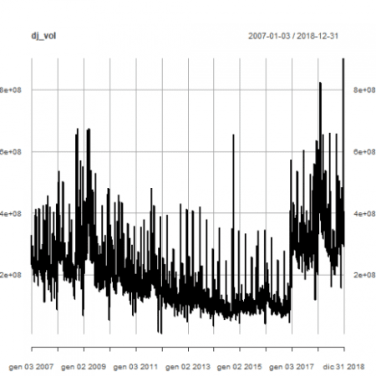](https://i2.wp.com/datascienceplus.com/wp-content/uploads/2019/01/unnamed-chunk-4-1.png?ssl=1)

It is remarkable the level jump at the beginning of 2017, something that we will investigate in part 4.

We transform the volume time series data and timeline index into a dataframe.

dj_vol_df <- xts_to_dataframe(dj_vol)

head(dj_vol_df)

*## year value*

*## 1 2007 327200000*

*## 2 2007 259060000*

*## 3 2007 235220000*

*## 4 2007 223500000*

*## 5 2007 225190000*

*## 6 2007 226570000*

tail(dj_vol_df)

*## year value*

*## 3015 2018 900510000*

*## 3016 2018 308420000*

*## 3017 2018 433080000*

*## 3018 2018 407940000*

*## 3019 2018 336510000*

*## 3020 2018 288830000*

**Basic statistics summary**

(dj_stats <- dataframe_basicstats(dj_vol_df))

*## 2007 2008 2009 2010*

*## nobs 2.510000e+02 2.530000e+02 2.520000e+02 2.520000e+02*

*## NAs 0.000000e+00 0.000000e+00 0.000000e+00 0.000000e+00*

*## Minimum 8.640000e+07 6.693000e+07 5.267000e+07 6.840000e+07*

*## Maximum 4.571500e+08 6.749200e+08 6.729500e+08 4.598900e+08*

*## 1. Quartile 2.063000e+08 2.132100e+08 1.961850e+08 1.633400e+08*

*## 3. Quartile 2.727400e+08 3.210100e+08 3.353625e+08 2.219025e+08*

*## Mean 2.449575e+08 2.767164e+08 2.800537e+08 2.017934e+08*

*## Median 2.350900e+08 2.569700e+08 2.443200e+08 1.905050e+08*

*## Sum 6.148432e+10 7.000924e+10 7.057354e+10 5.085193e+10*

*## SE Mean 3.842261e+06 5.965786e+06 7.289666e+06 3.950031e+06*

*## LCL Mean 2.373901e+08 2.649672e+08 2.656970e+08 1.940139e+08*

*## UCL Mean 2.525248e+08 2.884655e+08 2.944104e+08 2.095728e+08*

*## Variance 3.705505e+15 9.004422e+15 1.339109e+16 3.931891e+15*

*## Stdev 6.087286e+07 9.489163e+07 1.157199e+08 6.270480e+07*

*## Skewness 9.422400e-01 1.203283e+00 1.037015e+00 1.452082e+00*

*## Kurtosis 1.482540e+00 2.064821e+00 6.584810e-01 3.214065e+00*

*## 2011 2012 2013 2014*

*## nobs 2.520000e+02 2.500000e+02 2.520000e+02 2.520000e+02*

*## NAs 0.000000e+00 0.000000e+00 0.000000e+00 0.000000e+00*

*## Minimum 8.410000e+06 4.771000e+07 3.364000e+07 4.287000e+07*

*## Maximum 4.799800e+08 4.296100e+08 4.200800e+08 6.554500e+08*

*## 1. Quartile 1.458775e+08 1.107150e+08 9.488000e+07 7.283000e+07*

*## 3. Quartile 1.932400e+08 1.421775e+08 1.297575e+08 9.928000e+07*

*## Mean 1.804133e+08 1.312606e+08 1.184434e+08 9.288516e+07*

*## Median 1.671250e+08 1.251950e+08 1.109250e+08 8.144500e+07*

*## Sum 4.546415e+10 3.281515e+10 2.984773e+10 2.340706e+10*

*## SE Mean 3.897738e+06 2.796503e+06 2.809128e+06 3.282643e+06*

*## LCL Mean 1.727369e+08 1.257528e+08 1.129109e+08 8.642012e+07*

*## UCL Mean 1.880897e+08 1.367684e+08 1.239758e+08 9.935019e+07*

*## Variance 3.828475e+15 1.955108e+15 1.988583e+15 2.715488e+15*

*## Stdev 6.187468e+07 4.421660e+07 4.459353e+07 5.211034e+07*

*## Skewness 1.878239e+00 3.454971e+00 3.551752e+00 6.619268e+00*

*## Kurtosis 5.631080e+00 1.852581e+01 1.900989e+01 5.856136e+01*

*## 2015 2016 2017 2018*

*## nobs 2.520000e+02 2.520000e+02 2.510000e+02 2.510000e+02*

*## NAs 0.000000e+00 0.000000e+00 0.000000e+00 0.000000e+00*

*## Minimum 4.035000e+07 4.589000e+07 1.186100e+08 1.559400e+08*

*## Maximum 3.445600e+08 5.734700e+08 6.357400e+08 9.005100e+08*

*## 1. Quartile 8.775250e+07 8.224250e+07 2.695850e+08 2.819550e+08*

*## 3. Quartile 1.192150e+08 1.203550e+08 3.389950e+08 4.179200e+08*

*## Mean 1.093957e+08 1.172089e+08 3.112396e+08 3.593710e+08*

*## Median 1.021000e+08 9.410500e+07 2.996700e+08 3.414700e+08*

*## Sum 2.756772e+10 2.953664e+10 7.812114e+10 9.020213e+10*

*## SE Mean 2.433611e+06 4.331290e+06 4.376432e+06 6.984484e+06*

*## LCL Mean 1.046028e+08 1.086786e+08 3.026202e+08 3.456151e+08*

*## UCL Mean 1.141886e+08 1.257392e+08 3.198590e+08 3.731270e+08*

*## Variance 1.492461e+15 4.727538e+15 4.807442e+15 1.224454e+16*

*## Stdev 3.863238e+07 6.875709e+07 6.933572e+07 1.106550e+08*

*## Skewness 3.420032e+00 3.046742e+00 1.478708e+00 1.363823e+00*

*## Kurtosis 1.612326e+01 1.122161e+01 3.848619e+00 3.277164e+00*

In the following, we make specific comments to some relevant above shown metrics.

**Mean**

Years when Dow Jones daily volume has positive mean are:

filter_dj_stats(dj_stats, "Mean", 0)

*## [1] "2007" "2008" "2009" "2010" "2011" "2012" "2013" "2014" "2015" "2016"*

*## [11] "2017" "2018"*

All Dow Jones daily volume mean values in ascending order.

dj_stats["Mean",order(dj_stats["Mean",,])]

*## 2014 2015 2016 2013 2012 2011 2010*

*## Mean 92885159 109395714 117208889 118443373 131260600 180413294 201793373*

*## 2007 2008 2009 2017 2018*

*## Mean 244957450 276716364 280053730 311239602 359371036*

**Median**

Years when Dow Jones daily volume has positive median are:

filter_dj_stats(dj_stats, "Median", 0)

*## [1] "2007" "2008" "2009" "2010" "2011" "2012" "2013" "2014" "2015" "2016"*

*## [11] "2017" "2018"*

All Dow Jones daily volume median values in ascending order.

dj_stats["Median",order(dj_stats["Median",,])]

*## 2014 2016 2015 2013 2012 2011 2010*

*## Median 81445000 94105000 102100000 110925000 125195000 167125000 190505000*

*## 2007 2009 2008 2017 2018*

*## Median 235090000 244320000 256970000 299670000 341470000*

**Skewness**

Years when Dow Jones daily volume has positive skewness are:

filter_dj_stats(dj_stats, "Skewness", 0)

*## [1] "2007" "2008" "2009" "2010" "2011" "2012" "2013" "2014" "2015" "2016"*

*## [11] "2017" "2018"*

All Dow Jones daily volume skewness values in ascending order.

dj_stats["Skewness",order(dj_stats["Skewness",,])]

*## 2007 2009 2008 2018 2010 2017 2011*

*## Skewness 0.94224 1.037015 1.203283 1.363823 1.452082 1.478708 1.878239*

*## 2016 2015 2012 2013 2014*

*## Skewness 3.046742 3.420032 3.454971 3.551752 6.619268*

**Excess Kurtosis**

Years when Dow Jones daily volume has positive excess kurtosis are:

filter_dj_stats(dj_stats, "Kurtosis", 0)

*## [1] "2007" "2008" "2009" "2010" "2011" "2012" "2013" "2014" "2015" "2016"*

*## [11] "2017" "2018"*

All Dow Jones daily volume excess kurtosis values in ascending order.

dj_stats["Kurtosis",order(dj_stats["Kurtosis",,])]

*## 2009 2007 2008 2010 2018 2017 2011*

*## Kurtosis 0.658481 1.48254 2.064821 3.214065 3.277164 3.848619 5.63108*

*## 2016 2015 2012 2013 2014*

*## Kurtosis 11.22161 16.12326 18.52581 19.00989 58.56136*

**Box-plots**

dataframe_boxplot(dj_vol_df, "DJIA daily volume box plots 2007-2018")

[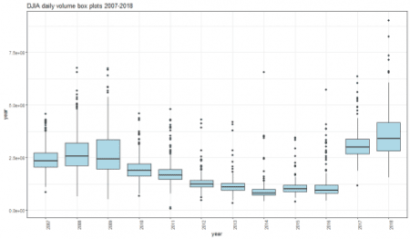](https://i2.wp.com/datascienceplus.com/wp-content/uploads/2019/01/unnamed-chunk-16-1.png?ssl=1)

The trade volume starts to decrease from 2010 and on 2017 a remarkable increase occurred. Year 2018 volume has been even larger than 2017 and other years as well.

**Density plots**

dataframe_densityplot(dj_vol_df, "DJIA daily volume density plots 2007-2018")

[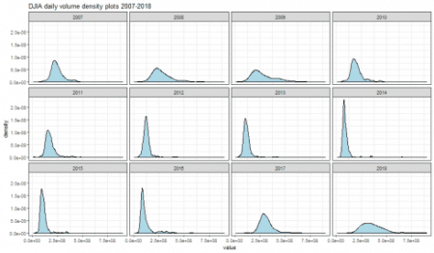](https://i2.wp.com/datascienceplus.com/wp-content/uploads/2019/01/unnamed-chunk-17-1.png?ssl=1)

**Shapiro Tests**

dataframe_shapirotest(dj_vol_df)

*## result*

*## 2007 6.608332e-09*

*## 2008 3.555102e-10*

*## 2009 1.023147e-10*

*## 2010 9.890576e-13*

*## 2011 2.681476e-16*

*## 2012 1.866544e-20*

*## 2013 6.906596e-21*

*## 2014 5.304227e-27*

*## 2015 2.739912e-21*

*## 2016 6.640215e-23*

*## 2017 4.543843e-12*

*## 2018 9.288371e-11*

The null hypothesis of normality is rejected for all years.

**QQ plots**

dataframe_qqplot(dj_vol_df, "DJIA daily volume QQ plots 2007-2018")

[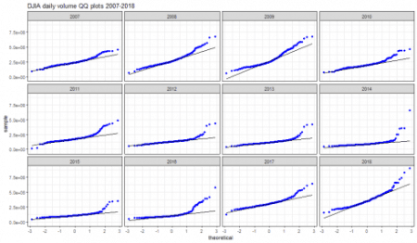](https://i2.wp.com/datascienceplus.com/wp-content/uploads/2019/01/unnamed-chunk-19-1.png?ssl=1)

QQplots visually confirm the non-normality of daily trade volume distribution.

**Daily volume log-ratio Exploratory Analysis**

Similarly to log-returns, we can define the trade volume log ratio as.

\[  
v_{t}\ := ln \frac{V_{t}}{V_{t-1}}  
\]  
We can compute it by CalculateReturns within the PerformanceAnalytics package and plot it.

dj_vol_log_ratio <- CalculateReturns(dj_vol, "log")

dj_vol_log_ratio <- na.omit(dj_vol_log_ratio)

plot(dj_vol_log_ratio)

[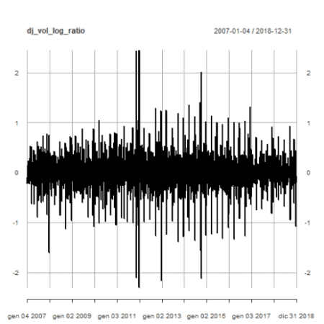](https://i0.wp.com/datascienceplus.com/wp-content/uploads/2019/01/unnamed-chunk-20-1.png?ssl=1)

Mapping the trade volume log-ratio time series data and timeline index into a dataframe.

dj_vol_df <- xts_to_dataframe(dj_vol_log_ratio)

head(dj_vol_df)

*## year value*

*## 1 2007 -0.233511910*

*## 2 2007 -0.096538449*

*## 3 2007 -0.051109832*

*## 4 2007 0.007533076*

*## 5 2007 0.006109458*

*## 6 2007 0.144221282*

tail(dj_vol_df)

*## year value*

*## 3014 2018 0.44563907*

*## 3015 2018 -1.07149878*

*## 3016 2018 0.33945998*

*## 3017 2018 -0.05980236*

*## 3018 2018 -0.19249224*

*## 3019 2018 -0.15278959*

**Basic statistics summary**

(dj_stats <- dataframe_basicstats(dj_vol_df))

*## 2007 2008 2009 2010 2011*

*## nobs 250.000000 253.000000 252.000000 252.000000 252.000000*

*## NAs 0.000000 0.000000 0.000000 0.000000 0.000000*

*## Minimum -1.606192 -1.122526 -1.071225 -1.050181 -2.301514*

*## Maximum 0.775961 0.724762 0.881352 1.041216 2.441882*

*## 1. Quartile -0.123124 -0.128815 -0.162191 -0.170486 -0.157758*

*## 3. Quartile 0.130056 0.145512 0.169233 0.179903 0.137108*

*## Mean -0.002685 0.001203 -0.001973 -0.001550 0.000140*

*## Median -0.010972 0.002222 -0.031748 -0.004217 -0.012839*

*## Sum -0.671142 0.304462 -0.497073 -0.390677 0.035162*

*## SE Mean 0.016984 0.016196 0.017618 0.019318 0.026038*

*## LCL Mean -0.036135 -0.030693 -0.036670 -0.039596 -0.051141*

*## UCL Mean 0.030766 0.033100 0.032725 0.036495 0.051420*

*## Variance 0.072112 0.066364 0.078219 0.094041 0.170850*

*## Stdev 0.268536 0.257612 0.279677 0.306661 0.413341*

*## Skewness -0.802037 -0.632586 0.066535 -0.150523 0.407226*

*## Kurtosis 5.345212 2.616615 1.500979 1.353797 14.554642*

*## 2012 2013 2014 2015 2016*

*## nobs 250.000000 252.000000 252.000000 252.000000 252.000000*

*## NAs 0.000000 0.000000 0.000000 0.000000 0.000000*

*## Minimum -2.158960 -1.386215 -2.110572 -1.326016 -1.336471*

*## Maximum 1.292956 1.245202 2.008667 1.130289 1.319713*

*## 1. Quartile -0.152899 -0.145444 -0.144280 -0.143969 -0.134011*

*## 3. Quartile 0.144257 0.149787 0.134198 0.150003 0.141287*

*## Mean 0.001642 -0.002442 0.000200 0.000488 0.004228*

*## Median -0.000010 -0.004922 0.013460 0.004112 -0.002044*

*## Sum 0.410521 -0.615419 0.050506 0.123080 1.065480*

*## SE Mean 0.021293 0.019799 0.023514 0.019010 0.019089*

*## LCL Mean -0.040295 -0.041435 -0.046110 -0.036952 -0.033367*

*## UCL Mean 0.043579 0.036551 0.046510 0.037929 0.041823*

*## Variance 0.113345 0.098784 0.139334 0.091071 0.091826*

*## Stdev 0.336667 0.314299 0.373274 0.301780 0.303028*

*## Skewness -0.878227 -0.297951 -0.209417 -0.285918 0.083826*

*## Kurtosis 8.115847 4.681120 9.850061 4.754926 4.647785*

*## 2017 2018*

*## nobs 251.000000 251.000000*

*## NAs 0.000000 0.000000*

*## Minimum -0.817978 -1.071499*

*## Maximum 0.915599 0.926101*

*## 1. Quartile -0.112190 -0.119086*

*## 3. Quartile 0.110989 0.112424*

*## Mean -0.000017 0.000257*

*## Median -0.006322 0.003987*

*## Sum -0.004238 0.064605*

*## SE Mean 0.013446 0.014180*

*## LCL Mean -0.026500 -0.027671*

*## UCL Mean 0.026466 0.028185*

*## Variance 0.045383 0.050471*

*## Stdev 0.213032 0.224658*

*## Skewness 0.088511 -0.281007*

*## Kurtosis 3.411036 4.335748*

In the following, we make specific comments to some relevant above-shown metrics.

**Mean**

Years when Dow Jones daily volume log-ratio has positive mean are:

filter_dj_stats(dj_stats, "Mean", 0)

*## [1] "2008" "2011" "2012" "2014" "2015" "2016" "2018"*

All Dow Jones daily volume log-ratio mean values in ascending order.

dj_stats["Mean",order(dj_stats["Mean",,])]

*## 2007 2013 2009 2010 2017 2011 2014*

*## Mean -0.002685 -0.002442 -0.001973 -0.00155 -1.7e-05 0.00014 2e-04*

*## 2018 2015 2008 2012 2016*

*## Mean 0.000257 0.000488 0.001203 0.001642 0.004228*

**Median**

Years when Dow Jones daily volume log-ratio has positive median are:

filter_dj_stats(dj_stats, "Median", 0)

*## [1] "2008" "2014" "2015" "2018"*

All Dow Jones daily volume log-ratio median values in ascending order.

dj_stats["Median",order(dj_stats["Median",,])]

*## 2009 2011 2007 2017 2013 2010*

*## Median -0.031748 -0.012839 -0.010972 -0.006322 -0.004922 -0.004217*

*## 2016 2012 2008 2018 2015 2014*

*## Median -0.002044 -1e-05 0.002222 0.003987 0.004112 0.01346*

**Skewness**

Years when Dow Jones daily volume log-ratio has positive skewness are:

filter_dj_stats(dj_stats, "Skewness", 0)

*## [1] "2009" "2011" "2016" "2017"*

All Dow Jones daily volume log-ratio mean values in ascending order.

dj_stats["Skewness",order(dj_stats["Skewness",,])]

*## 2012 2007 2008 2013 2015 2018*

*## Skewness -0.878227 -0.802037 -0.632586 -0.297951 -0.285918 -0.281007*

*## 2014 2010 2009 2016 2017 2011*

*## Skewness -0.209417 -0.150523 0.066535 0.083826 0.088511 0.407226*

**Excess Kurtosis**

Years when Dow Jones daily volume has positive excess kurtosis are:

filter_dj_stats(dj_stats, "Kurtosis", 0)

*## [1] "2007" "2008" "2009" "2010" "2011" "2012" "2013" "2014" "2015" "2016"*

*## [11] "2017" "2018"*

All Dow Jones daily volume log-ratio excess kurtosis values in ascending order.

dj_stats["Kurtosis",order(dj_stats["Kurtosis",,])]

*## 2010 2009 2008 2017 2018 2016 2013*

*## Kurtosis 1.353797 1.500979 2.616615 3.411036 4.335748 4.647785 4.68112*

*## 2015 2007 2012 2014 2011*

*## Kurtosis 4.754926 5.345212 8.115847 9.850061 14.55464*

**Box-plots**

dataframe_boxplot(dj_vol_df, "DJIA daily volume box plots 2007-2018")

[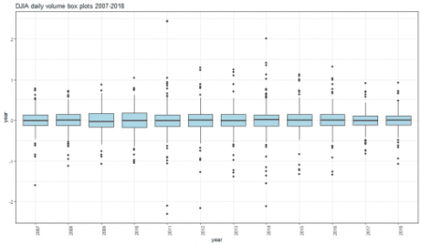](https://i0.wp.com/datascienceplus.com/wp-content/uploads/2019/01/unnamed-chunk-32-1-1.png?ssl=1)

The most positive extreme values can be spotted on years 2011, 2014 and 2016. The most negative extreme values, on years 2007, 2011, 2012, 2014.

**Density plots**

dataframe_densityplot(dj_vol_df, "DJIA daily volume density plots 2007-2018")

[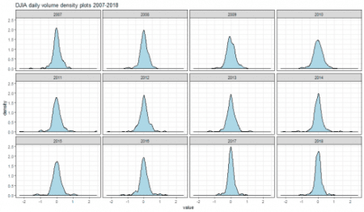](https://i1.wp.com/datascienceplus.com/wp-content/uploads/2019/01/unnamed-chunk-33-1-1.png?ssl=1)

**Shapiro Tests**

dataframe_shapirotest(dj_vol_df)

*## result*

*## 2007 3.695053e-09*

*## 2008 6.160136e-07*

*## 2009 2.083475e-04*

*## 2010 1.500060e-03*

*## 2011 3.434415e-18*

*## 2012 8.417627e-12*

*## 2013 1.165184e-10*

*## 2014 1.954662e-16*

*## 2015 5.261037e-11*

*## 2016 7.144940e-11*

*## 2017 1.551041e-08*

*## 2018 3.069196e-09*

Based on reported p-values, for all we can reject the null hypothesis of normal distribution.

**QQ plots**

dataframe_qqplot(dj_vol_df, "DJIA daily volume QQ plots 2007-2018")

[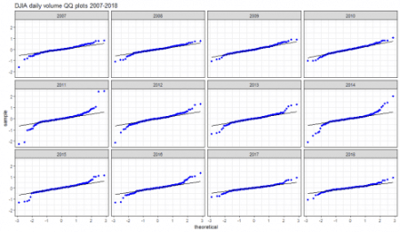](https://i1.wp.com/datascienceplus.com/wp-content/uploads/2019/01/unnamed-chunk-35-1.png?ssl=1)

Departure from normality can be spotted for all reported years.

Saving the current enviroment for further analysis.

save.image(file='DowEnvironment.RData')